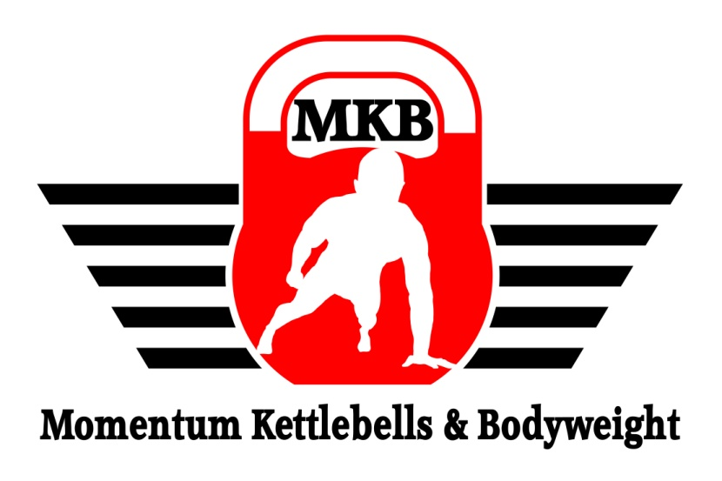

MOMENTUM

BODYWEIGHT

FOUNDATIONAL

PROGRESSIONS

SKILLS SYLLABUS

**MOMENTUM BODYWEIGHT FOUNDATIONAL PROGRESSIONS**

**SKILLS SYLLABUS**

**1. HOLDS**

Frog/Crow/Crane: Frog Stand

Crow Hold

Crane Pose

Side Crow

One Leg Crow

One Arm/One Leg Crow

Headstand: Tripod

Tripod Headstand

Elbow Headstand

Straddle Headstand

Ultimate Headstand

Handstand: Wall Handstand

Handstand Facing the Wall

Forearm Stand

Straddle Handstand

Strongman Style Handstand

Gymnastic Style Handstand

Hollowback Handstand

Handstand on Bars

Freestanding Handstand Press Up

One Arm Handstand

**MOMENTUM BODYWEIGHT FOUNDATIONAL PROGRESSIONS**

**SKILLS SYLLABUS**

**1. HOLDS cont.**

Elbow Lever: Closed Umbrella

Straddle Elbow Lever

Elbow Lever

One Arm Straddle Elbow Lever

One Arm Elbow Lever

Side One Arm Elbow Lever

Planche: Planche Lean

Tuck Planche

Straddle Planche

Scorpion Planche

Planche

**MOMENTUM BODYWEIGHT FOUNDATIONAL PROGRESSIONS**

**SKILLS SYLLABUS**

**2. Bar Moves**

Muscle Ups: Kipping Pull Up

Box Jump Muscle Ups

Negative Muscle up

Kipping Muscle Up

Strict Muscle Up

Reverse Grip Muscle Up

Back Lever: Skin the Cat

Tuck Back Lever

One Leg Back Lever

Straddle Back Lever

Back Lever

Reverse Grip Back Lever

One Arm Back Lever

Front Lever: Exaggerated Bar Hang

Tuck Front Lever

Straddle Front Lever

One Leg Front Lever

Front Lever Curls

Front Lever

**MOMENTUM BODYWEIGHT FOUNDATIONAL PROGRESSIONS**

**SKILLS SYLLABUS**

**3. Human Flag**

Clutch Flag: Side Plank

Low Hanging Clutch Flag

Tuck Clutch Flag

Clutch Flag

Clutch Lever

X Clutch Flag

Press Flag: Support Press

Chamber Hold

Vertical Flag

Low Hanging Flag

High Angle Flag

Bicycle Flag

Straddle Flag

High Support Press

Parallel Bar Flag

Press Flag (Body Facing Up)

Press Flag (Body Facing Sideways)

Tuck Shoulder Flag

Straddle Shoulder Flag

Full Shoulder Flag

Switch Grip Flag

One Arm Flag

Human Flag Crucifix

|  |  |  |  |
| --- | --- | --- | --- |
| **Dynamic Exercises**  **Standards** | | | |
| **Exercise** | **Baseline** | **Advanced** | **Elite** |
| Squat | 40 | 100 | 200 |
| Push Up | 30 | 60 | 100 |
| Hanging Knee Raise | 20 | 40 | 60 |
| Aussie Pull Up | 20 | 40 | 60 |
| Pike Press | 20 | 40 | 60 |
| Parallel Bar Dip | 15 | 30 | 50 |
| Pull Up | 10 | 20 | 30 |
| Hanging Leg Raise | 10 | 20 | 30 |
| Handstand Press | 1 | 10 | 20 |
| Pistol Squat | 1 | 10 | 20 |
| Shrimp Squat | 1 | 10 | 20 |
| Muscle Up | 1 | 10 | 20 |
| One Arm Push Up | 1 | 5 | 10 |
| One Arm Pull Up | - | 1 | 5 |

|  |  |  |  |
| --- | --- | --- | --- |
| **Isometric Exercises**  **Standards** | | | |
| **Exercise** | **Baseline** | **Advanced** | **Elite** |
| Headstand | 60 | 120 | 240 |
| Crow Hold | 60 | 120 | 240 |
| Back Bridge | 60 | 120 | 240 |
| L-sit | 20 | 60 | 120 |
| Elbow Lever | 20 | 60 | 120 |
| Free Handstand | 20 | 60 | 120 |
| Tuck Back Lever | 10 | 30 | 60 |
| Clutch Flag | 10 | 30 | 60 |
| Tuck Front Lever | 10 | 30 | 60 |
| Tuck Planche | 10 | 30 | 60 |
| Back Lever | - | 5 | 10 |
| Press Flag | - | 5 | 10 |
| Front Lever | - | 5 | 10 |
| Planche | - | 3 | 5 |